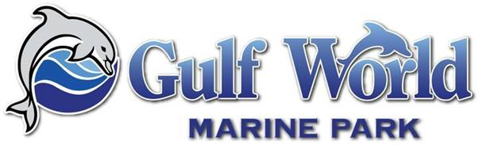

ANIMAL CARE AND TRAINING
Application Form

Thank you for your interest in Gulf World Marine Park’s animal care and training team position. Your submission of this application form signifies that you have read and agree to the following conditions:
- Be at least 18 years old and college student or recent graduate
- US Citizen
- Complete the required three – four month commitment of your term
- Work 40 hours a week
- Provide your own means of transportation.
- Applicants must be available for weekdays, weekends and holidays, morning and evening shifts.
- Ability to lift at least 50 lbs and work outside in the Florida extreme weather conditions.
- Able to demonstrate strong swimming abilities to include, treading water, freestyle swim above and below the water, lift yourself out poolside, etc.
- Term dates are flexible to accommodate individuals and their academic calendars.
- Gulf World Marine Park reserves the right to end a position at any time.
Please type this form and return it to us along with your resume and cover letter. These items must also be typed, and they should be combined into one packet. This packet may be submitted electronically or mailed. Incomplete packets will not be considered.
By signing and dating below you confirm that you meet and agree to all of the above conditions and that all information given is true. (Electronic signatures are acceptable)
X Date
Mailing Address: Fax Address:
Gulf World Marine Park 850-235-8957
Attn: Stephanie Nagle Email Address:
15412 Front Beach Road animalcare@gulfworldmarinepark.com
Panama City Beach, FL 32413

GULF WORLD MARINE PARK
ANIMAL CARE AND TRAINING DEPT
Application Form

Name:___________________________________________________ Date:________________

Permanent Address:____________________________________________________________
City:____________________________________ State:_________ Zip:__________________
Current Address:_______________________________________________________________
City:____________________________________ State:_________ Zip:__________________

Home Phone:)______________ Cell Phone:________________ Date of Birth:_____________
Email Address:_______________________________________

EDUCATION
College or University:___________________________________________________________
Major/Minor:____________________________________________ Years Completed:______

Proposed Internship Term (Circle One): Summer Fall Spring
Availability Dates: ___________________________________

Professional Memberships:________________________________________________________

Why do you wish to intern at Gulf World Marine Park? ________________________________________________________________________________________________________________________________________________________________________________________________

What are your opinions regarding marine mammals under human care?_____________________ ____________________________________________________________________________________________________________________________________________________________

What has been your most meaningful work-related or animal experience? Why?______________ ____________________________________________________________________________________________________________________________________________________________

Additional certifications and skills you believe make you the ideal candidate for this position. ___
____________________________________________________________________________________________________________________________________________________________

